# LAW iPad Experiment P 3

Robert Smith

120604

# Introduction

The *sentence composition template* allows a student to create a sentence in response to a question by selecting from lists of words. Figure 1 shows such an exercise 4.A.20.01.

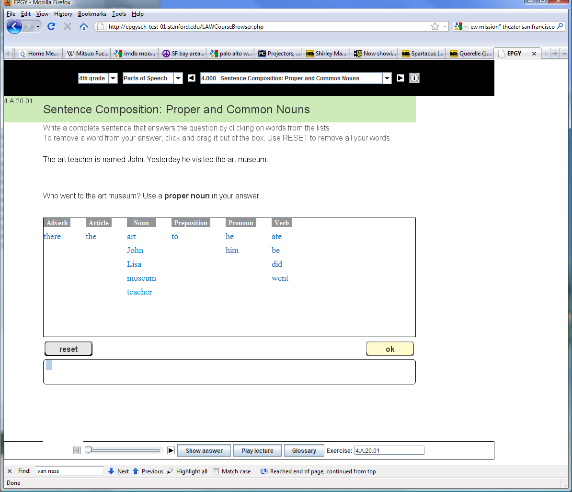

Figure 1: Sentence Composition

This may be fouind at 4th grade Parts of Speech 4.008 or by typing 4.A.20.01 into the bottom of the LAW Course Browser.

## Components

See the ZIP file I just sent.

The XML documents are files like 4.A.20.01.XML. Figure 2 shows this file.

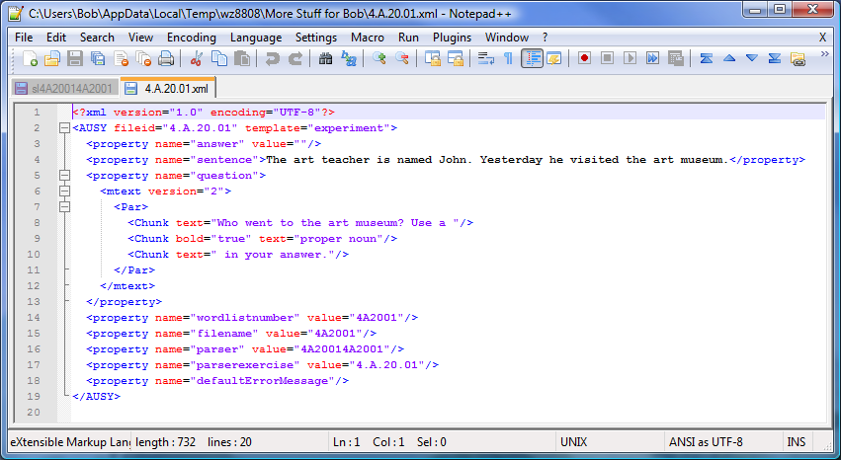

Figure 2: File 4.A.20.01.XML

1. The template attribute says "experiment". I guess this isn't an experiment anymore!
2. The property "sentence" goes at the top.
3. he property "question" (which contains some markup e.g., bold) is the question.
4. The property "wordlistnumber" tells us which wordlist to use. The wordlists are also stored in the ZIP.
5. The property "parser" points us to files with names like "slX" where X is the parser attribute. These files are also in the ZIP.
6. The lecture for this class of exercises is the SWF file. I will send you a MP4 encoding of it in an email.

## How It Works

The student clicks on words from the word lists. You can also drag but I don't think that will work very well. Each time a word is clicked it is concatenated onto the end of the answer. If you are dragging you can drag into the middle.

The words are in the wordhash_FILENAME file, where FILENAME is the "filename" property in the XML.

When the student clicks OK, the response is evaluated. This is done in two phases:

1. Responses are compared to the strings in the sl4A20014A2001 file (in this case). This file contains two lists of answers:
   1. The first list is the correct answers. If the student inputs anyone of these, the answer is correct.
   2. The second list, labeled "xs", are selected incorrect answers. There is a coded message for each of these selected incorrect answers.
2. If we don't get a determination from step 1, then what is done is that a parser on the server is invoked. Specifically, a URL with a querystring is sent to the host, and the host sends an XML document back with the results. *I still have a few questions about this so we will wait just a bit. For the present, just put up an error message saying that the parser is not available, and asking to try again. 2 tries maximum as before.*

## Implementation Notes

1. Make this another template type.
2. Use the same sounds and general conventions.
3. The icons at the bottom should be the same.
4. Note: these word lists get very long. We should perhaps think about how it will work when there are a lot of words and the student his using his finger instead of a mouse. *You are very free to think creatively about this, in fact the LAW team is expecting it!*
5. Please leave a place for the parser.

## Further Note

This is beginning to make a very long presentation. I suggest that we put a nice opening screen that can be used to make a selection. You can invent something pretty. I suggest:

1. Put the following buttons (or something):
   1. Identifying nouns
   2. Topic sentences of paragraphs
   3. Sentence Composition: Proper and Common Nouns
   4. One of each [this would select the first nouns, the first topic sentence, and the first sentence composition]
   5. Randomized [this would pick exercises randonly until all have been done].
2. You can also put an exit button there.
3. You could put the icon at the top with "Stanford Language Arts and Writing"
4. See what you come up with!